**Miniature Shetland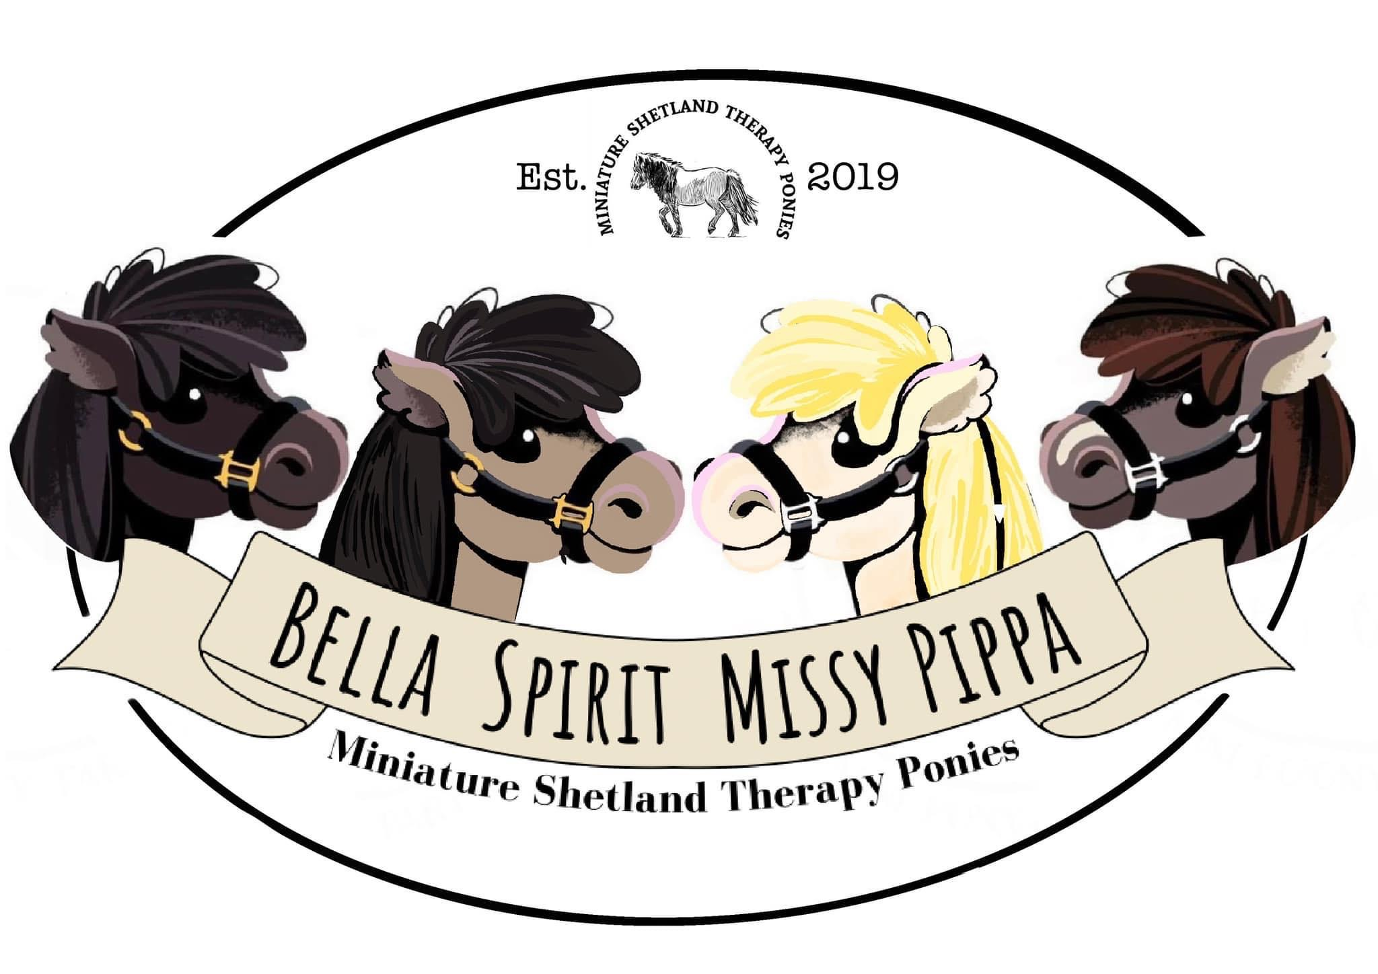 Therapy Ponies**

*EverDale Stables*

*2 Crowberry Lane , Middleton, Nr Tamworth, Staffordshire, B782AJ*

*07912 681564*

🚨 ***Important Notes for Adults*** 🚨

***\*\*\*\*\*\*\*\*\*\*\*\*\*\*\*\*\*\*\*\*\*\*\*\*\*\*\*\*\****

***Please Discuss Safety Aspects with Minors Prior to your Visit***

***\*\*\*\*\****

***Please Arrive 10 minutes Prior to your Booking Slot to be booked in with the team***

***\*\*\*\*\****

***Any Visitors with Additional Needs please let us know prior to your arrival any adaptations needed to make your experience more enjoyable***

***\*\*\*\*\****

***Please come Dressed Appropriately for Outdoor Activities & Wear Appropriate Footwear***

***(It can get Muddy)***

***\*\*\*\*\****

***Parking is Designated in our Field Parking Area***

***If the field are not suitable due to weather conditions Parking will be around the Fountain in front of the House***

***Parking will be Sign Posted as you arrive here at EverDale Stables***

***\*\*\*\*\****

***Please also be Mindful of others when Parking***

***\*\*\*\*\****

***Please Stay in Car Parking Area Until 10 Mins Prior to your Booking Time Slot***

***\*\*\*\*\****

***At this time please make your way up to the Booking in Gazebo & Gift Shop Area which is also Signposted***

***\*\*\*\*\****

***Toilet & Hand Washing Facilities are Sign Posted***

***Available At All Times***

***\*\*\*\*\*\*\*\*\*\*\*\*\*\*\*\*\*\*\*\*\*\*\*\*\*\*\*\*\*\*\*\*\*\*\*\*\*\*\*\*\*\*\*\*\*\*\*\*\*\*\*\*\*\*\*\*\*\*\*\*\****

🔔⛑️❤️***‍***🩹🔔

***Please do remember All Animals Can Kick and Bite, with all the training in the world unfortunate accidents can happen.***

***With this in mind………***

***Any Incidents with the Animals must Reported Immediately to a Member of Staff.***

***First Aid will be administered if required and accident form logged with both parties.***