Terms and Conditions for Bookings and Cancellations

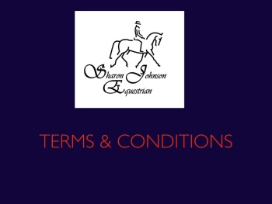

***Terms and Conditions.***

***When booking for any training session, clinic, event or course, you are agreeing to the following T’s & C’s.***

**Cancellations/Alterations/Refunds:**

 Should you wish to cancel or change a booking please be aware of the following:

Cancellations made within **48hrs** of the booked session will be charged at **50% of the full price.**

Cancellations made within **24hrs** of the booked session will be charged at **FULL PRICE**.

**REFUNDS** of **ANY BOOKING** if paid for by card or PayPal, or other outside providers, will be refunded**LESS the ADMIN FEE** of the provider, PLUS the amount retained for cancellations if under 48hrs, as stipulated above. E.g. If you pay £35 for a clinic by card and cancel within 48hrs of the clinic date you would receive £17.50 MINUS the card providers fees. If you cancel 7 days ahead, then you would receive £35 MINUS the card providers fees. Any questions on this, please do ask!

Fees will be waived should *severe weather conditions prevail, which deems it too dangerous to ride, and no other options are available, then the cancellation fee will be waived.

**CLINIC BOOKING**: Bookings are **non-transferable to other clinics**, unless a clinic is cancelled by Sharon Johnson Equestrian.

*The severe conditions include but are not limited to: SEVERE GALE FORCE WINDS (risk of damage to buildings, flying debris etc), Torrential flooding rain, Severe arena flooding, Ice/snow, "**Heavy Rain" is NOT covered in the cancellation policy. Excessive HEAT,**this means temperatures OVER 30 degrees, under this temperature sessions will continue if deemed safe. Please ask for confirmation if you are unsure.

***Cancellations*** *MUST be made by telephone as the email is not always available to check, please do not text. If you do not contact me, and I arrive for training, you will be liable to pay 100% of the charge.*

**PAYMENT**:

**Failure to pay at the time of booking (or within 24hrs) will result in your slot(s) being offered to others. Invoices which remain unpaid will incur additional charges.** Slots will NOT be “Held”.

**Payment methods:**

1) BACS Payments to Loyds Bank, Sort Code 30-90-49 Account Number 56774368 Please state your name and date of lesson

2) Online payments under the relevant booking section,

**Other notes**:

* If you run late, please be aware that to keep the day flowing your session will finish at the relevant time for your slot
* All riders 16 years of age and under must be accompanied by a suitable adult, and an emergency contact given
* Show jumping, body protectors are highly recommended, hats must be current standard, but may be fixed peak, although skull caps are highly recommended
* **CROSS COUNTRY RIDING**; **ALL riders MUST wear CURRENT standard body protectors, current standard hard hats with NON-FIXED PEAKS (skull Caps) and shoulders MUST be covered, no vest tops! In the event you turn up to a booked session minus any of these, then sadly you will not be allowed to ride due to Health & Safety rulings. No refunds will be given in such events.**