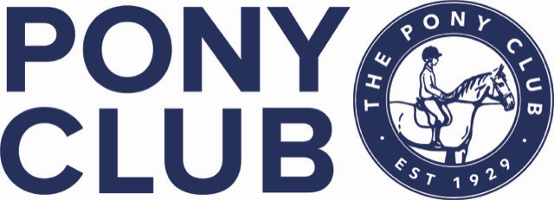

YORK AND AINSTY NORTH PONY CLUB
NEW YEAR SHOW JUMPING
Northallerton Equestrian Centre
3rd January 2024
OPEN TO ALL PONY CLUB MEMBERS

CLASS 1 50cm clear round (assisted but no lead reins)
CLASS 2 55cm – Kindly sponsored by Hymas Arenas – www.hymasarenas.co.uk
CLASS 3 60cm – Kindly sponsored by Toft Animal Supplies – www.toftanimalsupplies.co.uk
CLASS 4 70cm – Kindly sponsored by Derrings Kennels – www.derringskennels.co.uk
CLASS 5 80cm - Kindly sponsored by JYG Farriery –
Jason Gajczak DipWCF
CLASS 6 90cm – Kindly sponsored by Wilson Close Ltd

Class 1 £10 entry. Rosettes and sweets to all
Class 2 to 6 £15 entry. Rosettes to 6th Prizes in kind to third

Entries close 6pm Saturday 30th December
Times for all classes by 6pm 1st January 2024
No refunds after close of entries.

RULES AND CONDITIONS

- All classes to be run under Pony Club Show Jumping rules 2023
- Classes 3 – 6 will be decided on a timed shortened course immediately after any clear round.
- Any horse/pony and rider combination can only enter 2 classes, excluding clear round.
- Correct dress should be worn
- Hats to correct Pony Club standard and tagged must be worn at all times when mounted
- The organisers do not accept liability for any loss or damage, injury or illness to any persons or property whatsoever.
- The organisers have taken all precautions to ensure the health and safety of everyone present at the event.
- The organisers reserve the right to alter or amend the schedule/rules at any time.
- The judge’s decision is final.
- Any queries/objections must be taken up within 30minutes of the class finishing with £20 cash deposit.
- No skipping out in the car park and please take all your rubbish home.

